Wk 6:

Did humans evolve from apes?
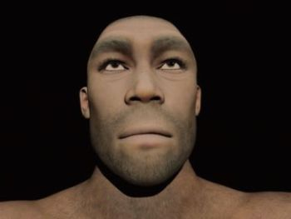Artists’ impressions of Homo erectus have most often depicted some really primitive, subhuman ‘ape-man’. However, the evidence that these were people (that should even share our species name) is mounting. So artists’ renditions are gradually shifting toward a much more obviously human appearance, as here.
by Don Batten and Warren Nunn
Humans did not evolve from chimps, gorillas, or orangutans. However, according to Darwinian evolution, humans are related to modern apes in that we shared a common ancestor.
Since Charles Darwin first proposed the basis for such ideas in the 19th century when he wrote On the Origin of Species by Means of Natural Selection, or the Preservation of Favoured Races in the Struggle for Life, molecules-to-man evolution has increasingly been taught as fact. Later, he fleshed out the idea of human evolution from a common ancestor with apes in The Descent of Man, and Selection in Relation to Sex.
The concept that humans and apes share a common ancestor contrasts with what we read in the Bible, because on the sixth day God said, “Let us make man in our image, after our likeness.” (Genesis 1:26) Further, in verse 27: “So God created man in his own image, in the image of God he created him; male and female he created them.” In Genesis chapter 2 it gives us more details, including that God made Adam from ‘dust’ and fashioned Eve, the first woman, from part of his side.
Thus, we can expect that by examining anything from germs to giraffes, that the data will best fit the presupposition of a perfectly created life-form that now exists in a world that is imperfect because of the Fall.
The two contrasting explanations for our existence—and for apes—have obvious philosophical/faith starting points because neither side can go back in time and observe how everything came into being. Both sides can only examine what we have in the present and draw conclusions from that.
Biblical creationists accept the Bible as an eyewitness account of that—for us—unobservable beginning. Thus, we can expect that by examining anything from germs to giraffes, that the data will best fit the presupposition of a perfectly created life-form that now exists in a world that is imperfect because of the Fall (Genesis 3). Therefore, we can expect (predict) that all life-forms now are not as genetically ‘perfect’ as their first parents.
So, ‘Did humans evolve from apes’ is really part of the bigger question, ‘Did humans and apes, and everything else, evolve?
The answer is no, nothing ‘evolved’ in the sense that Darwin proposed through naturalistic, unguided processes. Instead, God created everything (including Adam and Eve) in six, 24-hour days and it was very good, as we are told in Genesis 1:31.
Because we can trust the Bible as real history, we know that
(a) all life was created about 6,000 years ago,
(b) there was a global Flood of judgment on the world, which only eight humans and a limited number of creatures survived, and that
(c) all air-breathing land animals are descendants of those that walked off Noah’s Ark about 4,500 years ago.

The DNA evidence
Chimpanzees are said to be the closest relatives of humans. There is an oft-repeated claim that human-chimp DNA is 98% (or more) similar. This figure was based on rather primitive comparisons published in 1975. These early reports were popularized by evolutionists, but this was long before even the initial drafts of the human and chimp genome that were announced in 2001 and 2005, respectively. As explained in Evolution’s Achilles’ Heels, and other places, with our modern understanding of genetics, we now know that “98%” is simply not the case.¹ Even with genes that are similar between chimps and humans, the similarity is closer to 80%. If we consider the genes that chimps have that humans don’t and vice versa, the similarity drops to 70% or even less. However, the 98% myth persists.
An objective analysis of the claimed ape-men fossils shows that there is loads of wishful thinking involved.

Not enough time!
For the sake of the argument, let’s assume that the human and chimp genomes derived from a common genome in the six or seven million years since evolutionists say that humans and chimps split from the common ancestor. Then there is a need to account for 35,000,000 single-letter (base-pair) differences that had to arise and become fixed in the two genomes (i.e. the original letter in that location was replaced completely from the line to humans or the line to chimps); tens of millions of chromosomal rearrangements also had to occur, spread, and fix; as well as tens of millions of base-pair (‘letter’) insertions and deletions. (See Evolution’s Achilles’ Heels chapter 2 for more details). In short, there is simply insufficient time for evolutionists to account for the differences between chimp and human DNA, even with highly unrealistic assumptions in favour of it happening.²
Evolutionary time is measured in generations, not years. In six million years, there would only have been a few hundred thousand generations since chimps and humans were supposedly the same species. How then can there be enough time for so many brand-new genes to arise and be integrated? Each generation would have to select and retain an unbelievably huge number of mutations. This problem has come to be known as Haldane’s Dilemma. Despite claims to the contrary, Haldane’s Dilemma has never been solved. Modern knowledge of the genetic differences between chimps and humans shows that the problem is far greater for evolutionists than even Haldane imagined.³

Adam and Eve?
wikipedia.org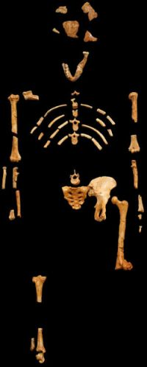Australopithecus afarensis (‘Lucy’) fossil parts. A top evolutionist anatomist concluded that this is a unique extinct primate that is anatomically further from both apes and humans than these are from each other—definitely not ‘in between’.
Studies of mitochondrial DNA, which is inherited from your mother, show that all humans had a single female ancestor.⁴ Likewise, studies of the Y-chromosome, which is only inherited from your father (to son!), show that all humans had a single male ancestor.⁵ Of course the evolutionary time scales attached to these individuals don’t match the Bible, but recalculations based on measurements of mutation rates in today’s world show that the biblical time frame is consistent with the data.
The world-wide genetic evidence in humans is consistent with the Bible’s history, that we are all descendants of Noah’s family, beginning some 4,500 years ago.⁶

Genetic decay
The number of mutations added to the human genome each generation is now known to be so high that it is inevitable that the human genome is deteriorating. This points back to a created perfection in the recent past.⁷ The same problem applies to all other complex creatures. This is another serious problem for the evolutionary idea that mutations and natural selection created humans and chimps from a common ancestor 6–7 million years ago. As the Russian geneticist, Alexey Kondrashov, remarked, “Why aren’t we dead 100 times over?” (he was assuming the evolutionary time frame).⁸

Fossils?
Are there really ‘ape-men’? An objective analysis of the claimed ape-men fossils shows that there is much wishful thinking involved, which is driven by the desire to ‘prove evolution’, or to justify the funding from National Geographic (e.g.), given to find ‘ape-men’.
There are a range of Homo species, including Neandertals. These are all descendants of Noah’s family. One exception is Homo habilis (‘handy man’), which some prominent evolutionary anthropologists acknowledge is actually a mixture of bones that came from non-human primates, such as australopithecines (Lucy’s kind), as well as humans (hence it not surprisingly looks like an ‘ape-man’). Homo habilis could justifiably be called an ‘invalid taxon’; that is, it never existed.
Other than that, objective numerical analysis shows that Australopithecus (‘southern ape’), supposedly the ancestors of humans (Homo spp.), are just types of apes that are not intermediate between chimps and humans.
That is, based on the fossils, there is no coherent story of human evolution from a common ancestor with apes, which is not surprising, considering the genetic evidence that shows they never existed.⁹

Conclusion
By reading the associated links to this article and books such as Evolution’s Achilles’ Heels, or by searching creation.com, you can learn more about this subject and when next someone asks you about any human-ape connection, you too will be able to gently suggest that they perhaps should take a closer look at the evidence.

The myth of ape-to-human evolution

Being popular doesn’t make an idea scientifically plausible
by Peter Line
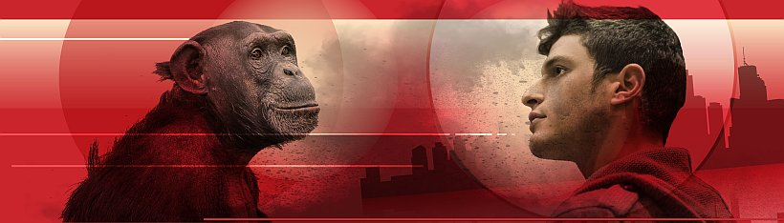©123rf.com/anolis01, ©123rf.com/theartofphoto
The public is frequently led to think that the evidence of humans evolving from an apelike common ancestor with chimps is simply overwhelming. The claim is often made in bombastic, even intimidating terms, such as in this example of ‘elephant hurling’ tactics by a prominent evolutionist:
“There are now tens of thousands of hominid fossils in museums around the world supporting our current knowledge of human evolution. The pattern that emerges from this vast body of hard evidence is consistent across thousands of investigations. All models, all myths involving singular, instantaneous creation of modern humans fail in the face of this evidence.” ¹
For most categories of ‘hominid’ claimed, there are usually even evolutionist experts who themselves will point out something that seriously questions, if not disqualifies, the idea that the fossils concerned are ‘in-between’ apes and humans.
However, when one starts to critically analyze these claims, things rapidly fall apart. For most categories of ‘hominid’ claimed, there are usually even evolutionist experts who themselves will point out something that seriously questions, if not disqualifies, the idea that the fossils concerned are ‘in-between’ apes and humans. For example:
Australopithecines (like ‘Lucy’): there are distinguished evolutionists who admit that these extinct primates were not anatomically intermediate between apes and humans.
Neandertals: probably most evolutionist paleoanthropologists now say that, although being robust in their anatomy, these are fully human.
Homo erectus and Homo heidelbergensis: some evolutionists classify them as ‘early’ and/or ‘archaic’ Homo sapiens. They had robust anatomy, as did the Neandertals, and like these there is no reason to believe that they were not fully human either.²
Homo habilis: whilst evolutionists generally regard these specimens as hominids (ape-men), when scrutinized this species appears to consist of specimens that should be grouped with the australopithecines, or other extinct apes, apart from a few that are likely Homo erectus.² Even some prominent evolutionists, whilst still saying they were hominids, have suggested most of the specimens in Homo habilis should be re-assigned to the genus Australopithecus. Hence, Homo habilis is a false category. Terms such as ‘wastebasket’, ‘grab bag’ and ‘garbage bag’ have been used by evolutionists to describe it.
Remove all those from the hugely impressive-sounding number of fossils in the above quote, and we’re left with a mere handful. Among these are the more recently discovered Homo florensiensis (aka ‘The Hobbit’) specimens. Here, too, leading evolutionists have pointed out that their features would be consistent with humans deformed by cretinism, from congenital iodine deficiency. Moreover, this magazine has highlighted the evidence that cretinism is also a likely cause of the puzzling (to evolutionists) features of the even more recently discovered Homo naledi fossils.³

Is human evolution even possible?
In any case, however, there are substantial biological reasons why ‘ape-men’ could never even have existed. A major one of these reasons is the so-called ‘waiting time problem’. No-one disagrees that to cause all of the anatomical changes required to transform an ape-like creature (the supposed common ancestor of chimps and humans) into a human would take millions of DNA mutations. This is because there are millions of nucleotide (‘DNA letter’) differences between chimps and humans. And in the evolutionary timeline, this is supposed to have happened in six to seven million years. The problem in a nutshell is that calculations show that it would take way too long for these specific mutations to arise and become established within a so-called ‘hominin’ population.⁴
For example, even for one point mutation (one letter change) to become fixed (established), the waiting time is a minimum of 1.5 million years.⁴ The number of nucleotides that can be selected for simultaneously is believed to be small, as it interferes with the selection of other nucleotides (called selection interference). It has been estimated that at most 1,000 beneficial mutations could become fixed in six million years—and using seven million, the upper end of the range, makes no practical difference.⁵
But this is only a minuscule fraction of the information needed to turn an ape into a human.
Note that this is only for independent, unlinked mutations, as according to John Sanford, an expert in this area (emphasis in original): “Selection for 1,000 specific and adjacent mutations (to create a 1,000-letter string) could not happen in 6 million years because that specific sequence of adjacent mutations would never arise, not even after trillions of years.” ⁶
Even if the genome (DNA) difference between chimps and humans were as little as 1%, as used to be widely touted, this still represents around 30 million nucleotide differences. And hence in the evolving hominid line, around 15 million nucleotide changes would need to take place (see box) compared to the 1,000 changes at most that could have happened in that time.

The hurdle multiplied
In short, even with the false idea of just 1% difference, the transition is impossible for mutations to achieve in the time available. But the problem for evolution is compounded because the chimp-human difference is now known to be not 1%, but likely at least 5% different and probably more.⁷
So the hurdle for evolution is even more insurmountable. A five-fold increase in the difference now means some 75 million nucleotide changes since the imagined common ancestor!
The problem is worse still, as in addition to this, the human genome is deteriorating, on a downward spiral towards ‘mutational meltdown’. This is due to the accumulation of genetic mutations, at a rate of some 100 point mutations per person per generation, with natural selection powerless to stop it.⁸
Making matters even worse for evolution theory, the amount of ‘junk’ DNA believed to be in the genome has shrunk considerably of late. The proportion evolutionists think is functional has now increased from about 3% to 80% or more. This is a problem, because it makes it far more likely for any mutation to be harmful, not neutral.⁹

Rising concerns
So not only is evolution unable to explain the arrival of information to turn apes into humans, it cannot even explain the preservation of existing information over timespans of millions of years.
All of this has raised alarm amongst some evolutionists. For example, Graur claims that for human population levels to be sustainable (to negate the effects of harmful mutations) no more than 25% of the human genome can be functional.¹⁰
But the estimate of the renowned ENCODE project is that at least 80% of our DNA is functional.¹⁰ So that means that humans should be extinct, because fertility is too low to compensate for the amount of deleterious mutations. But they are not, so therefore either
- the ENCODE estimate is totally wrong (highly unlikely) or
- the alleged ‘hominins’ (including modern-type humans) have not existed for the millions of years believed by evolutionists and the whole ape-to-human evolution story is false.
The problem of accumulating harmful mutations is even more serious than portrayed by evolutionists. Even if only 10% of the genome were functional, “extinction of all hominid lineages” would happen long before even the first waited-for beneficial mutation could be established in a ‘hominin’ population.¹¹
So not only is evolution unable to explain the arrival of information to turn apes into humans, it cannot even explain the preservation of existing information over timespans of millions of years.
The idea of human evolution means there was no original couple, no “first Adam” who fell into sin—and hence no logical reason for the sacrificial death of “the last Adam”, Jesus Christ (1 Corinthians 15:45). Many believers, even entire institutions of Christian higher learning, have been intimidated and/or indoctrinated into thinking they have to accept this notion. It is particularly ironic that this is happening right when the biological evidence is so strongly in favour of biblical creation.

Ape-to-human belief—clarifying terms and issues
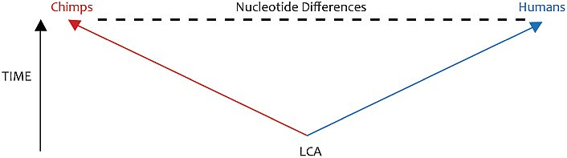
In evolutionary theory, both humans and chimpanzees are believed to have originated from the same apelike creature, or ‘last common ancestor’ (LCA), about 6 Ma (million years ago), and thereafter were on separate ‘evolving’ lineages to ultimately become today’s humans and chimps. Hominids (or hominins) is the name evolutionists usually apply to all individuals (whether apes, ‘ape-men’ or humans) on the imagined lineage from the LCA to modern humans.
So why does the argument in the main text focus on the DNA difference between chimps and humans today, when the issue is the difference between the LCA and humans today? Because they are directly related in evolutionary theory. As each lineage accumulates mutations, the DNA differences between them become greater. So the greater the difference between chimps (Cs) and humans (Hs) today, the greater the difference between humans today and the supposed LCA.
For example, if the human (H) and chimp (C) lineages changed at roughly the same rate, which most evolutionists assume, then a difference of 1% (= about 30 million nucleotide differences) between Hs and Cs today would mean that both differ by about 15 million nucleotides from the LCA. But if the H–C difference is 5% then that means a difference of about 75 million nucleotides between humans and the LCA, an even more impossible hurdle (see main text).
Even if the rates were different between the lineages of Hs and Cs it makes little practical difference, unless it is suggested that the human lineage rate was almost static (In fact, if anything, evolutionists would believe the human lineage changed the most, accumulating more differences from the LCA than the chimp lineage). But that would mean chimps derived from modern humans—who then must have lived 6 Ma, which would also falsify human evolution theory. And then you have the problem of explaining how chimps could establish double the number of nucleotide differences in 6 million years (if previously it was 75 million, it’s now 150 million)!

Refuting Evolution—Chapter 6
A handbook for students, parents, and teachers countering the latest arguments for evolution
by Jonathan Sarfati, Ph.D., F.M.

Humans: images of God or advanced apes?
First published in Refuting Evolution, Chapter 6
Humans are very different from animals, especially in the ability to use language and logic. Teaching about Evolution and the Nature of Science points out a number of contrasts between humans and apes on page 83. But Teaching about Evolution forcefully indoctrinates readers with the idea that humans have descended from a simple cell via ape-like ancestors.¹ The arguments used involve alleged apemen and DNA similarities. This chapter analyzes the fossil record, and also discusses the large difference in genetic information content between apes and humans.

Fossil apemen
The best-known fossil apemen are the extinct australopithecines (the name means ‘southern ape’). Teaching about Evolution on page 20 illustrates a series of five skulls: Australopithecus afarensis (‘Lucy’), A. africanus, early Homo, H. erectus, and H. sapiens (modern man). However, many evolutionists disagree with this picture. For example, Donald Johanson, the discoverer of ‘Lucy,’ places A. africanus on a side-branch not leading to man.² Anatomist Charles Oxnard performed a detailed analysis of different bones of A. africanus and concluded that it did not walk upright in the human manner and was more distinct from both humans and chimpanzees than these are from each other.³ More recently, Oxnard made the following comments about the australopithecines, including ‘Lucy’:
It is now recognized widely that the australopithecines are not structurally closely similar to humans, that they must have been living at least in part in arboreal [tree] environments, and that many of the later specimens were contemporaneous [living at the same time] or almost so with the earlier members of the genus Homo.⁴
Oxnard, an evolutionist, is one of several experts who do not believe that any of the australopithecines were on the human line.

Humans have always been humans
Marvin Lubenow, in his book Bones of Contention, also shows that the various alleged apemen do not form a smooth sequence in evolutionary ‘ages,’ but overlap considerably. He also points out that the various finds are either varieties of true humans (e.g. Neandertals, Homo erectus) or non-humans like the australopithecines, which probably includes the so-called Homo habilis. There are several lines of evidence to support this:
- Mitochondrial⁵ DNA analysis of a Neandertal skeleton found that the sequence differed from modern humans in 22 to 36 places, while the differences among modern humans are from 1 to 24 places.⁶ Despite some statistically invalid claims that this makes the Neandertals a separate species, the differences are within the range of modern humans.⁷ Also, DNA is quickly broken down by water and oxygen, so under favorable conditions, DNA might last tens of thousands of years at the most.⁸ This raises serious questions about the 100,000-year ‘age’ that some scientists have assigned to this skeleton.
- X-ray analysis of the semicircular canals of a number of apemen skulls showed that the Homo erectus canals were like those of modern humans, meaning they walked upright. But those of the A. africanus and A. robustus were like those of great apes. This shows they did not walk upright like humans, but were probably mainly tree-dwelling.⁹ ‘Homo habilis’ turned out to be even less ‘bi-pedal’ than the australopithecines.

Human and ape similarities?
Teaching about Evolution emphasizes physical and especially DNA similarities between human and other living organisms, and this is alleged to be evidence for evolution. However, again this is not a direct finding, but an interpretation of the data.
A common designer is another interpretation that makes sense of the same data. An architect commonly uses the same building material for different buildings, and a carmaker commonly uses the same parts in different cars. So we shouldn’t be surprised if a Designer for life used the same biochemistry and structures in many different creatures. Conversely, if all living organisms were totally different, this might look like there were many designers instead of one.
Another good thing about the common biochemistry is that we can gain nourishment from other living things. Our digestive systems can break down food into its building blocks, which are then used either as fuel or for our own building blocks.
Since DNA contains the coding for structures and biochemical molecules, we should expect the most similar creatures to have the most similar DNA. Apes and humans are both mammals, with similar shapes, so have similar DNA. We should expect humans to have more DNA similarities with another mammal like a pig than with a reptile like a rattlesnake. And this is so. Humans are very different from yeast but they have some biochemistry in common, so we should expect human and yeast DNA to be only slightly similar.
So the general pattern of similarities need not be explained by common-ancestry evolution. Furthermore, there are some puzzling anomalies for an evolutionary explanation—similarities between organisms that evolutionists don’t believe are closely related. For example, hemoglobin, the complex molecule that carries oxygen in blood and results in its red color, is found in vertebrates. But it is also found in some earthworms, starfish, crustaceans, mollusks, and even in some bacteria. The α-hemoglobin of crocodiles has more in common with that of chickens (17.5 percent) than that of vipers (5.6 percent), their fellow reptiles.¹⁰ An antigen receptor protein has the same unusual single chain structure in camels and nurse sharks, but this cannot be explained by a common ancestor of sharks and camels.¹¹
Similarities between human and ape DNA are often exaggerated. This figure was not derived from a direct comparison of the sequences. Rather, the original paper¹² inferred 97 percent similarity between human and chimp DNA from a rather crude technique called DNA hybridization. In this technique, single strands of human DNA were combined with DNA from chimpanzees and other apes. However, there are other things beside similarity that affect the degree of hybridization.
Actually, even if we grant that degree of hybridization entirely correlates with similarity, there are flaws. When proper statistics are applied to the data,¹³ they show that humans and chimps have only about 96 percent similarity. But we frequently hear larger figures bandied about—the alleged similarity grows in the telling!
A point often overlooked is the vast differences between different kinds of creatures. Every creature has an encyclopedic information content, so even a small percentage difference means that a lot of information would be required to turn one kind into another. Since humans have an amount of information equivalent to a thousand 500-page books, a 4 percent difference amounts to 40 large books (again, even if we assume that the hybridization data really correlates to gene sequence similarity).
That is, random mutation plus natural selection is expected to generate the information equivalent of 12 million words arranged in a meaningful sequence. This is an impossibility even if we grant the 10 million years asserted by evolutionists. Population genetics calculations show that animals with human-like generation times of about 20 years could substitute no more than about 1,700 mutations in that time.¹⁴

Embryo similarities?
Teaching about Evolution states on page 1:
As organisms grow from fertilized egg cells into embryos, they pass through many similar developmental stages.
Teaching about Evolution has no embryo drawings. However, many evolutionary books have drawings purportedly showing that embryos look very similar. They are based on the 1874 embryo diagrams by Ernst Haeckel, Darwin’ advocate in Germany, whose evolutionary ideas were instrumental in the later rise of Nazism. However, in 1997, a detailed study by Mike Richardson and his team,¹⁵ including actual photographs of a large number of different embryos, showed that embryos of different kinds are very distinct (see illustration below).
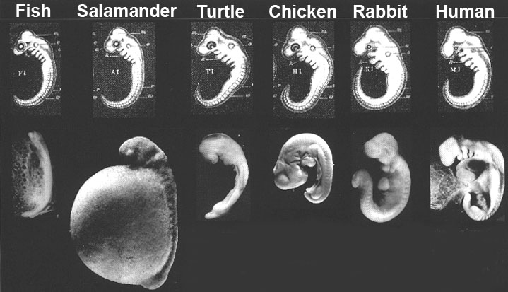Top row: Haeckel’s drawings of several different embryos, showing incredible similarity in their early ‘tailbud’ stage.
Bottom Row: Richardson’s photographs¹⁸ of how the embryos really look at the same stage. (From left: Salmo salar, Cryptobranchus allegheniensis, Emys orbicularis, Gallus gallus, Oryctolagus cuniculus, Homo sapiens.) Many modern evolutionists no longer claim that the human embryo repeats the adult stages of its alleged evolutionary ancestors, but point to Haeckel’s drawings (top row) to claim that it repeats the embryonic stages. However, even this alleged support for evolution is now revealed as being based on faked drawings.
Thus, the only way for Haeckel to have drawn them looking so similar was to have cheated. This study was widely publicized in science journals¹⁶ and the secular media, so a book published in 1998 has no excuse for being unaware that the idea of extensive embryonic similarities is outdated and based on fraud.¹⁷
More recently, Richardson and his team confirmed in a letter to Science that they still believe in evolution, and that the marked dissimilarities are consistent with this.¹⁹ But this contradicts the usual textbook²⁰ prediction from Darwinism that embryo development should go through similar stages as Haeckel’s faked drawings illustrate. If evolutionary theory predicts both similarities and differences, then it doesn’t really predict anything! On the basis of Richardson’ letter, evolutionists have claimed he really believes that Haeckel was ‘basically right.’²¹ But Richardson confirmed in a later letter to Science:
The core scientific issue remains unchanged: Haeckel’s drawings of 1874 are substantially fabricated. In support of this view, I note that his oldest ‘fish’ image is made up of bits and pieces from different animals—some of them mythical. It is not unreasonable to characterize this as ‘faking.’ … Sadly, it is the discredited 1874 drawings that are used in so many British and American biology textbooks today.’²²
A good account of Haeckel’s embryonic fraud was published in Creation magazine.²³

Mitochondrial Eve
Teaching about Evolution says on page 19:
According to recent evidence—based on the sequencing of DNA in a part of human cells known as mitochondria—it has been proposed that a small population of modern humans evolved in Africa about 150,000 years ago and spread throughout the world, replacing archaic populations of Homo Sapiens.
This evidence deals with comparing the DNA from mitochondria. This DNA is inherited only through the mother’ line. The similarities indicate that all people on earth are descended from a single human female. Even evolutionists have called her ‘Mitochondrial Eve.’
While this is consistent with the biblical account, we should note that it is not proof. Evolutionists contend that ‘Mitochondrial Eve’ was one of a number of women living. The mitochondrial line of the others would have died out if there were only males in any generation of descendants.
Evolutionists believed they had clear proof against the biblical account, because ‘Mitochondrial Eve’ supposedly lived 200,000 years ago. However, recent evidence shows that mitochondrial DNA mutates far faster than previously thought.²⁴ If this new evidence is applied to ‘Mitochondrial Eve,’ it indicates that she would have lived only 6,000–6,500 years ago.²⁵ Of course, this is perfectly consistent with the biblically indicated age of the ‘mother of all living’ (Gen. 3:20),²⁶ but an enigma for evolution/long age beliefs.
Interestingly, there is a parallel account with males: evidence from the Y-chromosome is consistent with all people being descended from a single man.²⁷ The data is also consistent with a recent date for this ‘Y-chromosome Adam.’²⁸

Conclusion
Teaching about Evolution aims to indoctrinate students with the belief that they are evolved animals and ultimately are, in effect, nothing more than a chance re-arrangement of matter. A senior writer for Scientific American had this inspiring comment:
Yes, we are all animals, descendants of a vast lineage of replicators sprung from primordial pond scum.²⁹
What this leads to is aptly shown by this dialog between two evolutionists. Lanier is a computer scientist; Dawkins is a professor at Oxford and an ardent Darwinist and atheist:
Jaron Lanier: ‘There’ a large group of people who simply are uncomfortable with accepting evolution because it leads to what they perceive as a moral vacuum, in which their best impulses have no basis in nature.’
Richard Dawkins: ‘All I can say is, That’ just tough. We have to face up to the truth.’³⁰

Is there really evidence that man descended from the apes?
These are ones that everyone agrees are not pre-human intermediates between apes and humans.
- Homo sapiens neanderthalensis (Neandertal man)—150 years ago Neandertal reconstructions were stooped and very much like an ‘ape-man’. It is now admitted that the supposedly stooped posture was due to disease and that Neandertal is just a variation of the human kind.
- Ramapithecus—once widely regarded as the ancestor of humans, it has now been realised that it is merely an extinct type of orangutan (an ape).
- Eoanthropus (Piltdown man)—hoax based on a human skull cap and an orangutan’s jaw. It was widely publicized as the missing link for 40 years.
- Hesperopithecus (Nebraska man)—based on a single tooth of a type of pig now only living in Paraguay.
- Pithecanthropus (Java man)—now renamed to Homo erectus. See below.
- Australopithecus africanus—this was at one time promoted as the missing link. It is no longer considered to be on the line from apes to humans. It is very ape-like.
- Sinanthropus (Peking man) was once presented as an ape-man but has now been reclassified as Homo erectus (see below).

Currently fashionable ape-men
These are the ones that adorn the evolutionary trees of today that supposedly led to Homo sapiens from a chimpanzee-like creature.
- Australopithecus—there are various species of these that have been at times proclaimed as human ancestors. One remains: Australopithecus afarensis, popularly known as the fossil ‘Lucy’.However, detailed studies of the inner ear, skulls and bones have suggested that ‘Lucy’ and her like are not on the way to becoming human. For example, they may have walked more upright than most apes, but not in the human manner. Australopithecus afarensis is very similar to the pygmy chimpanzee.
- Homo habilis—there is a growing consensus amongst most paleoanthropologists that this category actually includes bits and pieces of various other types—such as Australopithecus and Homo erectus. It is therefore an ‘invalid taxon’. That is, it never existed as such.
- Homo erectus—many remains of this type have been found around the world. They are smaller than the average human today, with an appropriately smaller head (and brain size). However, the brain size is within the range of people today and studies of the middle ear have shown that Homo erectus was just like us. Remains have been found in the same strata and in close proximity to ordinary Homo sapiens, suggesting that they lived together.
Conclusion: There is no fossil evidence that man is the product of evolution. The missing links are still missing because they simply do not exist. The Bible clearly states, “then the Lord God formed man of the dust of the ground, and breathed into his nostrils the breath of life; and man became a living being.” (Genesis 2:7).

Could humans have evolved from an ape-like creature through slow and gradual mutations?
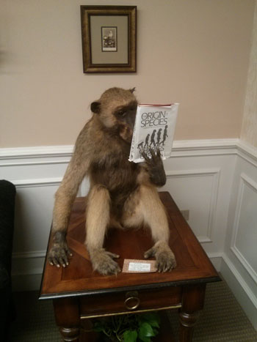
Hello,
I have had a question about apes-to-man evolution involving mutations. I’ve read on your website that mutations don’t add any genetic information. So my question is, is it possible that an ape-like creature could’ve evolved into human resulting from mutations? Is it possible that mutations could of changed the ape’s features little by little and each mutation could make a feature that results in the ape becoming more of a human? Thanks!
NW
CMI’s Joel Tay responds:
Dear NW,
Thank you for writing to us.
Concerning the phrase, “Mutations cannot create new information”, it is necessary to read some of our more recent articles on this issue. In this article, “Can mutations create new information”, Dr Robert Carter explains why he does not agree with this statement.
There is a common myth that Human-Chimp DNA is 98% similar. This figure was based on some early experimental evidence (Reassociation kinetics) in 1975. What the researchers did was to extract DNA from two species, add them to the same test tube, warmed the tube up, and then measured how much light was absorbed by the combination as it cooled. These early reports were popularized by some evolutionists but this was long before even the initial drafts of the human and chimp genome that were announced in 2001 and 2005, respectively. As explained in Evolution’s Achilles’ Heels, and other places, with our modern understanding of genetics, we now know that “98%” is simply not the case.
T‎here is simply insufficient time for evolutionists to account for the differences between chimp ‎and human DNA‎
Many portions of the genome are so different that a one-on-one comparison between human and chimpanzee DNA is impossible. For example, humans have several hundred protein-coding genes (all tightly integrated into the spliceosome) that are absent in chimps, the “similar” genes are scattered about in different places in the genome, and there are also entire gene families that are found in humans that are not in chimps. In the segments of the genome that are similar enough to make a comparison, the percentage of actual similarity between human and chimp DNA is probably closer to 80% – and when we compare the human and chimp Y chromosomes, the figure is even lower. These drastic differences between human and chimp DNA cannot be accounted for by evolutionary mathematics, so the statement that humans and chimps are 98% identical is nothing more than evolutionary dogma.

Human-ape similarities?
Evolutionists believe that humans and chimps split from a common ancestor 5–7 million years ago. As ‘evidence’, for decades, evolutionists have been claiming that humans and chimpanzees are nearly identical. One often hears “98% similarity”, or something similar. But is this true? Consider the following:
- The published chimpanzee genome was built using the human genome as a guide, a ‘scaffold’ upon which to ‘hang’ short sequence reads from the chimpanzee sequencing project. Thus, there is a built-in extra degree of similarity. Note how they presupposed common ancestry with chimpanzees without actually testing it.
- The chimpanzee genome was built before the revelation that nearly all sequencing projects were contaminated by human DNA.² Since chimpanzees and humans are close, it is expected that human contamination adds another degree of false similarity.
- The human and chimpanzee Y chromosomes are radically different from one another. Half of the chimpanzee Y chromosome is “missing” and the rest is only ~70% identical to human. Evolutionists struggle to explain how such a tremendous difference happened, even given their assumption that we have been separated by millions of years.
- There are about 35 million single-letter differences that separate our two species, a huge number of short insertions and deletions, and thousands of genomic rearrangements. Under evolutionary theory, they have to account for these in just a few hundred thousand generations, in 7 million years at the most.
- If you randomly take sections of the chimpanzee sequencing data and try to find matches in the human genome, and vice versa, you will find less than 90% similarity. And, many sections of the chimpanzee genome simply do not exist in humans. Clearly, the degree of similarity is much less than most people claim!
In the supposedly six million years since evolutionists believe humans and chimps split from a common ancestor, there is a need to account for 35,000,000 single letter differences that had to arise and become fixed in the two genomes (i.e. the original letter in that location was lost completely); tens of millions of chromosomal rearrangements had to occur, spread, and fix; as well as tens of millions of base pair insertions and deletions. (See Evolution’s Achilles’ Heels, p.75 for more details). In short, there is simply insufficient time for evolutionists to account for the differences between chimp and human DNA. Evolutionary time is measured in generations, not years. In six million years, there would only have been a few hundred thousand generations since chimps and humans were supposedly the same species. How then can there be enough time for so many brand-new genes to arise and be integrated? Each generation would have to select and retain an unbelievably huge number of mutations. This problem has come to be known as Haldane’s dilemma. Despite many claims to the contrary, Haldane’s Dilemma has never been solved. If anything, in recent years, our understanding of genetics has demonstrated that the problem is far greater for evolutionists than even Haldane imagined.¹
Evolutionists have in the past cited junk DNA as a potential mechanism for solving this problem. ‘junk DNA’ refers to what was thought to be non-functioning portions of DNA. It was assumed that these were vestigial genomic ‘debris’ left behind from our evolutionary past. Since 97% of the DNA in the genome does not code for proteins, evolutionists proposed that these sections of ‘junk DNA’ would be free to mutate and evolve over time without significant consequences for the organism. The concept of junk DNA was extremely important for evolutionists as it was a last gasp in justifying how so many mutations could have arisen and remained fixed in the genome in such a short period of time (i.e. generations).
Unfortunately for the evolutionist, most scientists have now rejected the idea of junk DNA. The non-coding portions in the genome are now known to be almost completely functional. You might want to read these articles: here, here, and here on functions of ‘junk’ DNA. The general lack of junk DNA is yet another Achilles heel of evolutionary mathematics and argues strongly against biological evolution.
The general lack of junk DNA is yet another Achilles heel of evolutionary mathematics and argues strongly against biological evolution.
I would also highly recommend reading up on what Dr Carter calls the four dimensional genome. In my opinion, this is even more devastating to evolution than Haldane’s dilemma and the lack of Junk DNA. The four dimensional genome is one of my personal favorite argument against evolution from genetics. When the human genome was first sequenced, we thought that we could understand how the genome worked by sequencing the linear string of nucleotides. But this simplified understanding was naïve as we now know that this is only one of four dimensions of DNA as an information storage mechanism. If this is something you are interested in, I would highly recommend having a look at Dr Carter’s talk, The High Tech Cell, as well as Evolution’s Achilles’ Heels. Both resources discuss the four dimensional genome.
In a recent edition of Creation magazine (Vol. 38, No. 4, 2016), we also have an interview with Geneticist, Dr Jeffrey Tomkins, where he discusses human and chimp DNA. I have included an excerpt from that article that relates to your question. (See “Chromosome 2 Fusion?” below).
I hope that helps,
Joel Tay

Chromosome 2 Fusion?
Humans have 23 chromosome pairs. Apes have 24. Evolutionists often claim that two smaller chromosomes fused to create human chromosome 2 at some early point in human history. They base this claim on the fact that the banding patterns in two smaller chimpanzee chromosomes are similar to the banding pattern on human chromosome 2. However:
- The bands actually do not line up perfectly, thus the supposed evidence for the fusion event on human chromosome 2 is in the wrong place.
- While chromosome fusions have been documented in other species, there are no other examples of two chromosomes joining at the ends. The telomeres help prevent this.
- If a head-to-head fusion occurred, it should leave behind evidence of the original telomeres, i.e. characteristic repetitive telomere sequence (TTAGGG), in both forwards and backwards direction. There are telomere motifs in this area, but they rarely repeat in a tandem fashion as they would if they were truly telomeric, and they can be found in other parts of the genome as well.
- Since every chromosome has a centromere, a head-to-head fusion should produce a chromosome with two centromeres. But centromeres have a distinctive repeating sequences of 171 units that are specific for a species. Human Chromosome 2’s supposed vestigial centromere looks nothing like a chimp centromere, but it does match several other places in the non-centromeric human genome.
- If a head-to-head fusion occurred, there is no way that it happened in the middle of an active gene, for two halves of a single gene would not be found on different chromosomes. Yet the supposed fusion site is located in the middle of a highly expressed and tightly controlled human gene.
Considering all this, there is little evidence that human chromosome 2 is the result of an ancient fusion event.

Image of God or image of an ape?

British Museum of Natural History exhibition stumped on evolution
by Dominic Statham
On 18th December 2015, the British Museum of Natural History (BMNH) opened their new ‘Human Evolution’ exhibition. A few days later, I travelled to London to take a look.
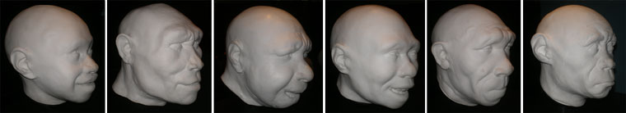Fig 1. Left to right: the BMNH’s reconstructions of the faces of Homo sapiens (juvenile), Homo erectus, Homo neanderthalensis (female), Homo antecessor (juvenile), Homo heidelbergensis and Homo floresiensis (female). Credit: Francis Gearty.
Click image to enlarge.
It begins with the usual assertion of ‘the fact of evolution’ with a sign which reads, “The fossil record shows that the human family tree is made up of many ancient relatives, and that ape-like ancestors evolved into us.” Most significantly, however, it goes on to say, “Exactly who our direct ancestors were within this family tree is a subject of scientific debate”, and this admission is reflected throughout the exhibition. Speaking of the first display, museum paleontologist Professor Chris Stringer commented,
Well, we’ve attempted here to represent about 7 million years of human evolution on one diagram and you’ll notice a lot of skulls there with different species names … But you’ll notice also, unlike many of these depictions, we haven’t joined them up with lines of ancestors and descendants and that’s a reflection of the uncertainty about how these forms are related …¹
Also significant is that the chart contains just two main groups, one identified as ‘humans’ and other as ‘australopithecines’—with nothing bridging them.
In other words, despite there being “a lot” of different species, he had found it impossible to put them in an order showing a clear evolutionary progression from ape-like creatures to man.
Also significant is that the chart contains just two main groups, one identified as ‘humans’ and other as ‘australopithecines’—with nothing bridging them. ‘Species’ such as Homo neanderthalensis (‘Neanderthal man’) and Homo erectus (‘Peking man’) are placed in the blue area and described as ‘humans’, with just one species, Homo sapiens, in the subgroup, ‘modern humans’. Species such as Australopithecus afarensis and Australopithecus africanus are placed in the orange area and described as ‘australopithecines’. Since ‘australopithecine’ means ‘southern ape’ one might reasonably conclude that all these different ‘species’ (collectively known as ‘hominins’)² should be classified as either ‘apes’ or ‘humans’, with no clear examples of ‘ape-men’.
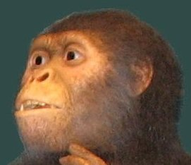Fig. 2. Hypothetical reconstruction of Australopithecus afarensis by St Louis Zoo, Missouri. Note the ‘whites’ in the eyes giving the creature a more human-like appearance and an impression of intelligence. Credit: Ivan Burgener.
Further inside the exhibition are reconstructions of the heads and faces of various ‘human species’—Homo sapiens, Homo erectus, Homo neanderthalensis, Homo antecessor, Homo heidelbergensis and Homo floresiensis (fig. 1). What is so striking, however, is their similarities rather than their differences. They are all, clearly, so very human. In contrast the fossil skulls of australopithecines are so clearly ape-like (figs 2 and 3). Again, where are the transitional forms linking australopithecines to humans? Towards the end of the exhibition there is a full reconstruction of a ‘Neanderthal man’, leaving no doubt that, despite all that’s been said about this ‘species’ in the past, the museum scientists understand him to be fully human (fig. 4).
Given their difficulties identifying a plausible evolutionary progression, showing how australopithecines slowly turned into humans, how can evolutionists be so confident that this is what actually happened? The answer, I have come to see, has very little to do with science.

Why are so many scientists convinced of evolution?
First, evolutionists are committed to the doctrine of ‘philosophical naturalism’ (otherwise known as ‘scientism’ or ‘materialism’), the belief that everything can and should be explained only by natural processes. According to Professor Paul Davies, “Science takes as its starting point that life wasn't made by a god or a supernatural being: it happened unaided and spontaneously, as a natural process.”³
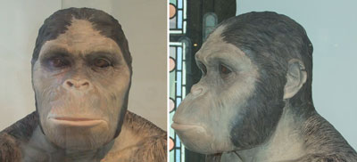
Fig. 3. BMNH’s hypothetical reconstruction of Australopithecus africanus in a previous exhibition. Again, note the use of artistic licence to give the impression of human-like intelligence.
Second, living apes and humans share many similarities and this is taken as proof that we share a common evolutionary ancestor. A book on sale in the museum’s shop is titled, 99% Ape: How Evolution Adds Up, and argues that our DNA differs from that of chimpanzees by only 1%.⁴ (See fig. 5.)
Third, they believe the rocks to be millions of years old and that the fossils they contain document the long history of life on Earth. Remains of creatures found in deeper rocks are understood to be older and therefore the ancestors of those found nearer the surface. In their thinking, australopithecine fossils are found in rocks millions of years older than human fossils, so we must have evolved from them.

Science and scientism
According to Professor Paul Davies, ‘Science takes as its starting point that life wasn't made by a god or a supernatural being: it happened unaided and spontaneously, as a natural process.’
Modern science flourished in the seventeenth century because people came to see the universe as being governed by natural laws which act consistently from one day to the next.⁵ Rainbows, for example, were understood to appear in the sky, not because a god had supernaturally put them there, but because natural processes had produced them. Based on this thinking, seventeenth century scientists such as Isaac Newton sought to discover these laws and, wherever possible, state them in mathematical terms.
People like Professor Davies cited above take this thinking one step further. They argue that, not only is the universe today governed by natural laws, but also that it came into being through natural laws. For them it is axiomatic (self-evident) that the origins of space, galaxies, stars, planets and even life on Earth can all be explained without reference to the act of a supernatural being. This, however, is not science but scientism,⁶ because no experiments or mathematics or logic have ever shown it to be true. It is simply what some people have chosen to believe. Significantly, this ‘worldview’ is quite different to that held by many of the founders of modern science.^{7,8} People like Newton believed in a special creation and a universe which, having been produced supernaturally, would thereafter be governed by natural laws. In fact, Newton himself was a biblical creationist and accepted the account of the origins taught in the book of Genesis.⁹
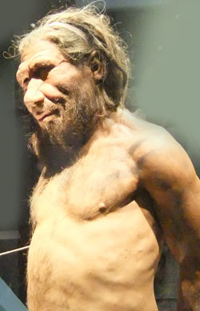Fig. 4. BMNH’s reconstruction of Homo neanderthalensis (‘Neandertal man’) showing him to be fully human.

Does sharing DNA with chimpanzees prove evolution?
Even if humans did share 99% of their DNA with chimpanzees, this would not prove that we share a common evolutionary ancestor. A perfectly reasonable alternative explanation could be that we share a common designer.¹⁰ Nor would it demonstrate that we are 99% chimp. We share 50% of our DNA with bananas; yet we are clearly not half banana.
In fact, the figure of 99% similarity is very outdated and many evolutionists would agree that it is far lower than this—perhaps no higher than 81%.¹¹ Remarkably, scientific papers as far back as 2007 refer to the ‘myth of 1%’.¹² If we consider just the Y chromosome, the chimp has only two-thirds as many distinct genes or gene families as humans and only 47% as many protein-coding elements as humans.¹³

Are the rocks really millions of years old?
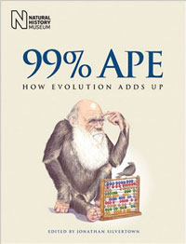Fig. 5. A book on sale in the BMNH’s bookshop incorrectly stating that we share 99% of our DNA with chimpanzees.
Evolutionists claim that this is an indisputable fact of science based mainly on radioactive dating.¹⁴ What they don’t tell people, however, is that different radioactive ‘dating methods’ can lead to very different conclusions about the age of the samples being tested. For example, some wood was found buried in basalt rock in the Crinum coal mine in Australia. The wood was ‘dated’ by the radiocarbon method and yielded a result of around 45,000 years. The basalt was ‘dated’ by the Potassium-Argon method and yielded a result of 45,000,000 years.¹⁵ Moreover, numerous scientific observations point to the rocks being far younger than evolutionists claim.¹⁶ Particularly strong evidence for the fossils not being millions of years old arises from the discovery of preserved organic material in dinosaur remains. This includes DNA, proteins, blood vessels, soft tissues and blood cells. None of these would be expected to last millions of years.¹⁷
Biblical creationists argue that the majority of the sedimentary rocks were laid down in the great Flood recorded in Genesis 6–8. Most if not all of the australopithecine fossils might be understood to be the remains of creatures that were buried at this time. The human fossils are understood to be post-Flood, and many are thought to be the remains of people who perished in caves soon after the dispersion from Babel—hence the term ‘caveman’. We would agree with the museum’s classification of the fossils into these two groups (australopithecines and humans), although we would not say the different humans belonged to different species. Significantly, studies of DNA samples have shown that Homo neanderthalensis and Homo erectus both interbred with modern humans making clear that they were not separate species.¹⁸ Some modern humans have Neandertal-like features, such as a pronounced brow ridge and a sloping forehead, an example being the Russian boxer, Nikolai Valuev.

Why does it matter?
If we are simply products of a mindless evolutionary process, then we are nothing more than bags of chemicals. If so, then we have no more value than bacteria and we are not responsible for our actions.¹⁹ Moreover, our desires—whatever they might be—must be perfectly natural because that’s how evolution turned us out. Can you imagine telling this to a group of teenagers? If human life is of no greater value than that of plants or animals, then abortion, euthanasia, experiments on embryos and human cloning are all perfectly reasonable.
In contrast, if we carry the image of God as the Bible teaches (Genesis 1:26–27), then we have great value and a responsibility to honour that image in ourselves and others. To deface it by hurting others is crime against God and against humanity. To abort a baby or to deliberately end the life of an elderly person is to ‘play God’.
How we view ourselves will be greatly influenced by what we believe about our origins. Museums and churches, therefore, should be very careful what they teach about these things.

Refuting Evolution 2—Chapter 12
A sequel to Refuting Evolution that refutes the latest arguments to support evolution (as presented by PBS and Scientific American).
by Jonathan Sarfati, Ph.D. with Michael Matthews

Argument: Evolution of mankind
Evolutionists say, ‘The unique characteristics of the human species can easily be explained.’
First published in Refuting Evolution 2, Chapter 12
PBS 6—‘The Mind’s Big Bang’—attempts to explain the biggest difference between humans and animals: our mind, including the advantages of language. However, it makes hardly any attempt to prove evolution; rather, it assumes it, and makes up stories to explain the differences given this assumption. PBS 1 had already paved the way with misleading arguments about ape men and DNA similarity.

Have humans evolved from ape-like creatures?
The similarity between apes and humans is one of evolutionists’ favorite arguments for common descent based on common appearance. The PBS series shouts ‘yes’ in answer to the question, ‘Have humans evolved from ape-like creatures?’ and episode 1 showed a number of fossils of alleged apemen for cumulative effect. But this was very deceptive—some of the alleged apemen it showed are not even accepted by evolutionists as genuine intermediates anymore. For example, it showed an old photograph of Louis Leakey with Zinjanthropus (now Paranthropus) boisei or ‘Nutcracker Man,’ sometimes called a robust australopithecine. But this was long ago relegated to a side branch on man’s alleged evolutionary tree.
PBS 1 also claimed that the DNA of chimps and humans was ‘98 percent’ similar, and said it’s ‘only a couple of spelling errors.’ While the 98 percent is debatable,¹ claiming a ‘couple’ of differences is outright deception—humans have 3 billion ‘letters’ (base pairs) of DNA information in each cell, so a two percent difference is actually 60 million ‘spelling errors’! Of course, this is not ‘error’ but twenty 500-page books worth of new information that needs to be explained by mutation and selection. Even if we grant 10 million years to the evolutionists, population genetics studies show that animals with human-like generation times of about 20 years could accumulate only about 1,700 mutations—not 60 million—in their genomes in that time frame.²

Missing links found?
Donald Johanson, the discoverer of the alleged missing link ‘Lucy,’ was featured on PBS 2 titled ‘Great Transformations.’ Supposedly, humans are part of evolution, despite our unique abilities to design and create works of art. Allegedly, about 7 million years ago, our ancestors swung down from the trees and became bipedal. Then they could gather and carry food, and this food could be higher in energy. This fed bigger brains, which in turn helped food to be gathered more efficiently, in a positive feedback. But Johanson said that there are still differences in the skeletons of chimps and humans, e.g., differently shaped pelvises, different angles where the spine meets the skull, and the way we walk with our knees together while apes walk with their legs far apart.
But PBS offered little actual evidence. The fossil record is full of holes, and ‘missing link’ claims become boring after a while because they are so often discredited.³ The nearest thing to ‘evidence’ was Liza Shapiro, University of Texas, showing how flexible the lemur’s spine was. The lemur can move on all fours, but leap upright. But this doesn’t show how a quadruped can make all the transformations needed to turn it into a proper biped.
Scientific American also asserts that we have found a series of hominid fossils that link humans to an ape-like ancestor:
The historical nature of macroevolutionary study involves inference from fossils and DNA rather than direct observation … . For instance, evolution implies that between the earliest-known ancestors of humans (roughly five million years old) and the appearance of anatomically modern humans (about 100,000 years ago), one should find a succession of hominid creatures with features progressively less ape-like and more modern, which is indeed what the fossil record shows. [SA 80]
Scientific American also makes this amazing claim:
Perhaps 20 or more hominids (not all of them our ancestors) fill the gap between Lucy the australopithecine and modern humans. [SA 83]
How could these alleged ‘20 or more hominids’ fill the gap if they are ‘not all our ancestors’? That is, they have fallen out of the gap and into a side alley.

The power of presuppositions
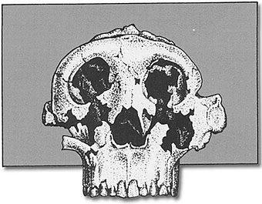Three different interpretations of what the fossil Australopithecus boisei looked like from the same skull remains.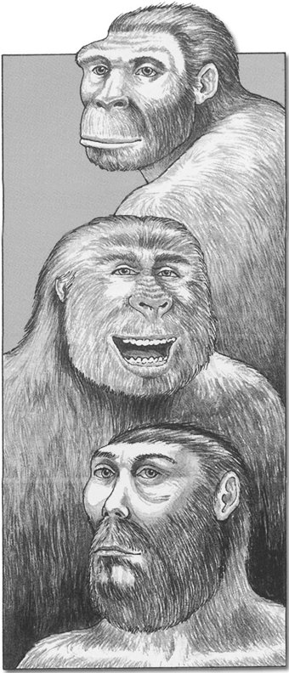This shows the imagination of scientists and artists. Such “reconstructions” can be made ape-like or human, depending on the artists’s viewpoint or belief system.

The ‘links’ are still missing!
The apemen fossils are often based on fragmentary remains, and this is true of the latest of a long series of ‘missing link claims,’ Ardipithecus ramidus kadabba. But when more bones are excavated, the specimens are found to be either man or non-man (e.g., australopithecine).
Even if there were such a chain of similar creatures, common appearance does not prove common origin. But the claim is groundless, anyway. What the fossil record shows in reality, even granted the evolutionary ‘dating’ methods, is that this alleged clear-cut progression exists only in the minds of evolutionary popularists. Marvin Lubenow shows that the various alleged ‘apemen’ do not form a smooth sequence in evolutionary ‘ages,’ but overlap considerably.⁴ For example, the timespan of Homo sapiens fossils contains the timespan of the fossils of Homo erectus, supposedly our ancestor. Also, when the various fossils are analyzed in depth, they turn out not to be transitional or even mosaic. The morphology overlaps too—the analysis of a number of characteristics indicates that Homo ergaster, H. erectus, H. neanderthalensis as well as H. heidelbergensis, were most likely ‘racial’ variants of modern man, while H. habilis and another specimen called H. rudolfensis were just types of australopithecines.⁵ In fact, H. habilis is now regarded as an invalid name, probably caused by assigning fragments of australopithecines and H. erectus fossils into this ‘taxonomic waste bin.’

Out of Africa?
PBS 6 begins deep in a cave in France, where archaeologist Randy White explores cave paintings, allegedly 30–40 ka (kilo-annum = thousand years ago). The narrator intones about finding out how our ancestors became truly human, and how the mind was born. Then the scene shifts to the Rift Valley in East Africa, where ‘humans began.’
Supposedly our branch of the evolutionary tree split off 6 Ma (mega-annum = million years ago) from the line leading to chimps. Our ancestors swung down from the trees and became bipedal about 4 Ma, tools were first made 2.5 Ma, early humans began to leave Africa 2 Ma but they would all eventually become extinct, while truly modern humans left Africa 50–60 ka. This is all ‘documented’ with computer graphics, then by actors.

Internal evolutionary squabbles overlooked
As shown later, PBS 6 advocates what is called the ‘out of Africa’ model, without saying so. This is where modern humans came out of Africa and replaced less evolved hominids that had emerged from Africa much earlier. But there is another evolutionary idea, called the ‘multi-regional’ or ‘regional-continuity’ hypothesis, where the hominids that emerged from Africa 2 Ma evolved into modern humans in many parts of the world. This is one of the most vitriolic debates among paleoanthropologists, yet this episode presents only one side. The acrimony between the proponents of these rival theories is due, according to anthropologist Peter Underhill of Stanford University, to: ‘Egos, egos, egos. Scientists are human.’ We think both sides are right in their criticisms of each other, because humans did not evolve at all!⁶

Human distinctives
PBS 6 showed a skull ‘dated’ 100 ka, and said that the owner could have been dressed in modern clothes and it would hardly raise an eyebrow. Massachusetts Institute of Technology psychologist Steven Pinker pointed out that modern human babies anywhere in the world can learn any language in the world, and how to count, as well as grow to understand computers. So he suggested: ‘The distinctively human parts of our intelligence were in place before our ancestors split off into the different continents.’
The humans who allegedly left Africa 50–60 ka encountered the hominids that had left earlier, that had evolved into Neandertals. They were bigger and stronger than we are, had bigger brains, and were characterized by having a big nose, receding chin (prognathism) and forehead, almost no cheek, and prominent brow ridges (supraorbital tori). But they were less creative, with almost no symbolic life or art, and unstructured burial of their dead. Their spear tips were easy to make by chipping stone, but had low range so were used mainly for stabbing. Supposedly they learned by imitation, rather than passing on information via a highly developed language.
The late arrivals, however, had a structured burial of their dead, and made long-range spears with some difficulty by carving antlers for tips. They also invented a spear thrower. Most importantly, they had a sophisticated language that enabled them to transmit information across both distance and time.
They also produced art and culture. PBS 6 demonstrates a ‘spit painting’ technique they could have used for their cave paintings, and shows that they may have played music by using speleothems (stalactites and stalagmites) as natural percussion instruments.

Creationist view of cavemen and Neandertals
The Bible teaches that the first man, Adam, was made from dust and the first woman was made from his rib. Also, Genesis 1 teaches that living creatures reproduce ‘after their kind’—see chapter 4. Therefore, we would expect no continuity between man and the animals.

Cavemen and the Bible
One important event recorded in the Bible is the confusion of languages at Babel. The obvious effect was to produce the major language families, from which modern languages have developed. But the division of people according to their newly created language groups had other effects, too.
Babel resulted in the isolation of small people groups, each containing a fraction of the total gene pool. This would help fix certain characteristics. Natural selection and sexual selection would act on these, producing the different people groups (‘races’) we see today.
Also, some people groups would be isolated from civilization. Consider even the typical small extended family group today, if suddenly isolated from civilization, e.g., on a desert island. Many such groups would not have the ability to smelt metals or build houses. Therefore, they would have to use the hardest material available (stone) and make use of already-existing structures (caves). Different family groups would also have different levels of artistic ability. So it shouldn’t be too difficult to accept that humans such as Homo erectus and Neandertals were probably post-Babel humans who became isolated from major cities, and developed certain physical characteristics because certain genes became fixed due to the small population and selective factors. The notion of a ‘stone age’ is fallacious—rather, it’s a cave/stone technology stage of different people groups. Some people even today have this level of technology, but they live at the same time as us, and are just as human.

Human brain uniqueness
PBS 6 quotes the psychologist Pinker again, who points out that the human brain contains 100 billion cells, and more importantly, it is wired with 100 trillion connections, ‘wiring it in precise ways to produce intelligence.’ But he attributed this to mutations over 10s and 100s of thousands of years. He has yet to find a single mutation that could increase information, let alone the colossal number required to wire the cerebral supercomputer correctly.
Supposedly, this would have been driven by selection for ability to manipulate others. Better language control means better social control.

Human v. chimp minds
The PBS episode turns to psychologist Andrew Whiten of the University of St. Andrews in Scotland, who tested how young children learned. (Incidentally, on the lintel above the entryway to the school is the Latin ‘In principio erat Verbum,’ the Vulgate translation of John 1:1, ‘In the beginning was the Word’). He tested children with small models of people, where one ‘person’ puts an object in one place, goes away, then another ‘person’ takes this object and hides it somewhere else. Then the first ‘person’ returns, whereupon the child is asked where he or she would look for the object. A three year old suggests the new hiding place, while a five year old correctly realizes that the first ‘person’ would have no way of knowing that the object had been moved, and would look in the place he left it. (Sometimes this is called the ‘Sally-Anne’ test, where the ‘Sally’ doll hides something in the absence of ‘Anne.’) Whiten concluded that by the age of three:
A child cannot ascribe actions to others. But by the age of five, the child’s brain has developed the capacity for stepping into someone else’s mind. [PBS 6]
The program contrasts this with chimpanzees, which are incapable of this at any age, ‘No chimp has passed the test of attribution of false belief.’

Language
There are about 6,300 languages in the world today. They all have certain constraints, and obey strict rules, called syntax. This enables us to hierarchically organize information, which is something chimps cannot do, even with the best training in signing.
There is a certain window of opportunity for learning syntax by imitation that gradually closes after the age of seven. PBS 6 shifted to Managua, the capital of Nicaragua, where we meet ‘Mary No-name.’ She was born deaf, and no one taught her sign language, so she never had a chance to learn syntax. She is still intelligent enough to communicate with some signs, but only to people who know the context.
PBS 6 documents how after the Nicaraguan revolution, U.S. sign language experts tried to teach sign language to deaf people from isolated villages, but failed. But the children developed their own sign language instead, which is a real language with proper syntax and as much capacity for expressing complex thought as spoken language. They wanted to communicate with other people like themselves rather than have a language imposed upon them.
Deaf people actually process sign language with the same areas of the brain that hearing people use to process spoken language, including Broca’s area and Wernicke’s area. This is shown by deaf patients who have damage to either area, who have an equivalent type of aphasia (language impairment) in sign language to that which a hearing person would suffer in spoken language.⁷

Evolution of language?
None of the above has anything to do with evolution. The language processing areas are unique to humans, and enable us to use syntax in both written and sign language.
All the same, atheist Richard Dawkins of Oxford University presents his usual storytelling on PBS 6 about how language conferred a selective advantage, so left more offspring. It’s interesting that the only topic this well-known propagandist for neo-Darwinism is interviewed on is language, although Dawkins’s field is biology, not linguistics. It’s also notable that the PBS series did not show Dawkins promoting his rabid atheistic religion, which he makes plain is a main reason for his promotion of Darwin. Presumably the producers didn’t want to make the materialistic implications of evolution too obvious to an American public that might still be repulsed by overt atheism.
PBS 6 explains how Robin Dunbar of Liverpool University has researched the way people use language, and he rejects the idea that the main function is to exchange information. Rather, about two-thirds is social interaction, which he called ‘gossip.’ So natural selection favored those with the most refined social skills, which would have the advantages of holding big groups together and being able to find out information about third parties.

Difficulties with language evolution
It’s one thing to claim that languages evolved, but it’s another to provide a mechanism. Evolutionists usually claim that languages evolved from animal grunts. Some even claim that the continuing change of languages is just like biological evolution. However, actual observations of language present a very different picture.
First, ancient languages were actually extremely complex with many different inflections. There is no hint of any build-up from simpler languages. For example, in the Indo-European family, Sanskrit, Classical Greek and Latin had many different noun inflections for different case, gender, and number, while verbs were inflected for tense, voice, number, and person. Modern descendants of these languages have greatly reduced the number of inflections, i.e., the trend is from complex to simpler, the opposite of evolution. English has almost completely lost inflections, retaining just a few like the possessive ‘s.’
English has also lost 65–85 percent of the Old English vocabulary, and many Classical Latin words have also been lost from its descendants, the Romance languages (Spanish, French, Italian, etc.).
Second, most of the changes were not random, but the result of intelligence. For example: forming compound words by joining simple words and derivations, by adding prefixes and suffixes, by modification of meaning, and by borrowing words from other languages including calques (a borrowed compound word where each component is translated and then joined). There are also unconscious, but definitely non-random, changes such as systematic sound shifts, for example those described by Grimm’s law (which relates many Germanic words to Latin and Greek words).⁸

Memes
Dawkins said on PBS 6, ‘The Mind’s Big Bang’:
The only kind of evolutionary change we’re likely to see very much of is not genetic information at all, it’s cultural evolution. And if we put a Darwinian spin on that, then we’re going to be talking about the differential survival of memes, as opposed to genes. [PBS 6]
Dawkins proposed the meme idea long ago in his book The Selfish Gene, and psychologist Sue Blackmore of the University of West of England has been one of his recent champions. She said on PBS 6:
Memes are ideas, habits, skills, gestures, stories, songs—anything which we pass from person to person by imitation. We copy them … just as the competition between genes shapes all of biological evolution, so it’s the competition between memes that shapes our minds and cultures.
Nowadays I would say that memetic evolution is going faster and faster, and it has almost entirely taken over from biological evolution … .
The more educated you are, the less children you have. That is memes fighting against genes. [PBS 6]
Now memes have apparently found a new home, the internet, and it has actually enslaved us, we are told.
Blackmore even believes that the idea of the ‘self’ is an illusion produced by competing memes in the brain. But under her own system, we must ask her, ‘Who is (or rather, what are) actually proposing this idea?’!
But it becomes ridiculous when things such as the internet, birth control, any invention, insulin, are called ‘memes.’ A term that describes everything really describes nothing. All that she’s done is apply the same label to just about anything, but this adds nothing to our knowledge.
It’s no wonder that the evolutionist Jerry Coyne called Blackmore’s book ‘a work not of science, but of extreme advocacy.’ He says that memes are ‘but a flashy new wrapping around a parcel of old and conventional ideas.’ Coyne also believes that evolutionary psychology is non-science (and nonsense). Coyne is no creationist sympathizer but an ardent—but ineffective—opponent of creation.⁹
The Discovery Institute critique of the PBS series points out that, if the likes of Eugenie Scott were truly concerned about non-science being taught in the science classroom, she would oppose evolutionary psychology and memetic evolution as well, and certainly not support the use of this PBS series in science classrooms.¹⁰ No, what she’s opposed to are challenges to her materialistic faith.

Conclusion
From all the money and time lavished on the PBS ‘Evolution’ series, major articles in science journals, and political campaigns to keep teachers from presenting alternatives to evolution in schools, it is evident that the evolutionists fear the increasing spread of creationist information, despite their best efforts at censorship. So they are desperate to counteract this information. But their efforts don’t withstand scientific scrutiny, and in the end any reasonable observer would have to admit that evolution is a deduction from a materialistic belief system. It is philosophy/religion dressed up as ‘science.’

Who was ‘Java man’?
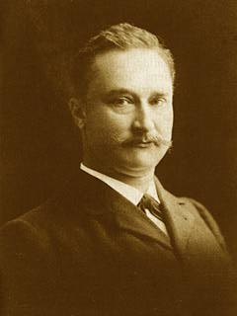Photograph of Dubois in middle age. | 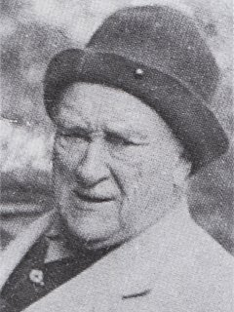Dubois shortly before his death
Late last century a Dutch physician, Eugene Dubois, set sail to the Dutch East Indies (now called Indonesia). Completely enamoured by the theory of evolution, he had come to believe for some reason that he would find the elusive ‘missing link’ between humans and apes in that part of the world.
In 1892 on the island of Java, he found a thigh-bone, which to all intents and purposes was like that of modern humans. About a year earlier in the same location he had found a large skull-cap, and later three teeth. These were not necessarily from the same individual: the skullcap and the leg-bone were about 15 metres (50 feet) apart.
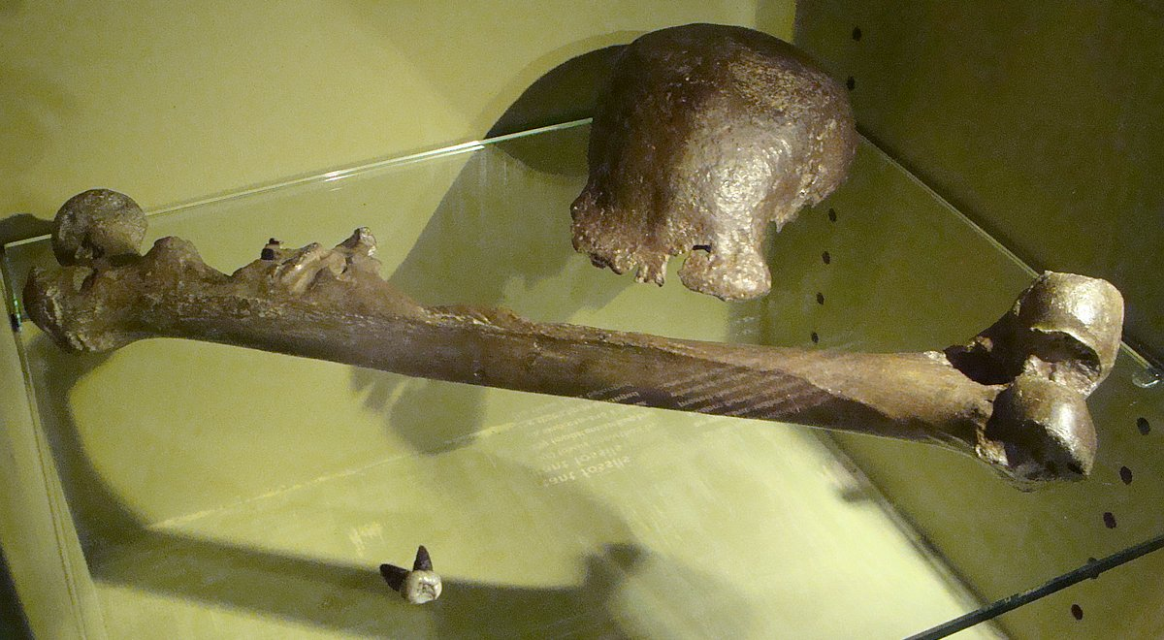The bones of ‘Java man’
The creature from which the skullcap came appeared to have had a brain size of 900 cc (about two-thirds that of the average modern man—one must of course allow for the difficulty of estimating brain size from only a part of the skull). There is no reason to insist that the skullcap and the leg bone came from the same individual. But Dubois had found his ‘missing link’ and it eventually became widely accepted as such, in spite of the fact that a leading authority had identified two of the teeth as those of an orangutan, and the other as human.
A leading authority had identified two of the teeth as those of an orangutan, and the other as human.
‘Java man’ was trumpeted around the world as indisputable proof of human evolution. Textbooks and magazines were filled with fanciful reconstructing of ‘Java man’, who had been given the impressive-sounding scientific name of Pithecanthropus erectus (‘erect ape-man’).
Naturally, the bones did not show whether their owner (or owners) had much body hair or not. Yet drawings of ‘Java man’ all showed the required amount of hair, the usual club in the hand, and so on. Although no face bones had been found, suitably ‘half-ape, half-man’ features were reconstructed in artists’ drawings.

Other skulls found
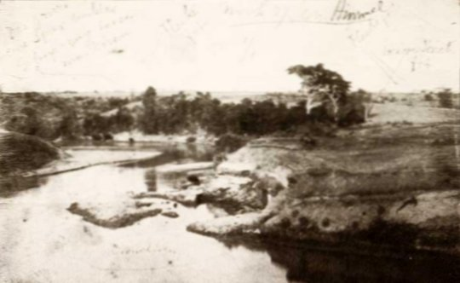Dubois’ photograph of his excavation site on the Solo River.
For a full 30 years, Dubois did not announce to the scientific community that he had also found two human skulls in the same general location and level in a gravel deposit. These were the so-called Wadjak skulls. Many have said that this was because he knew it would detract from the readiness with which his ‘Java man’ find would be accepted as man’s ancestor. However, from his own writings and other sources, Dubois apparently had a suspicious nature, and even locked his ‘Java man’ find away for years, even though many were convinced it was the ‘missing link’.
The skullcap may have belonged to a large extinct ape, and the leg bone to an ordinary human.
‘Java man’ has been renamed so as to now belong to the category of Homo erectus. However, readers should be aware that though there are indeed reasonable specimens which have been named Homo erectus (of disputed status in this whole question, but that’s another matter) there is no reason to believe that ‘Java man’ necessarily even belonged to this category, nor had any objective existence at all.
The skullcap may have belonged to a large extinct ape, and the leg bone to an ordinary human. Unfortunately, the occasional reference text still features ‘Java man’ as somehow evidence of an evolutionary origin of man.

Did Dubois recant? Revising the record
Evolutionist articles of textbooks and anthropological journal articles have often written that Dubois eventually renounced his ‘Java man’ and claimed it was merely a giant gibbon. Such authorities have naturally been quoted to this effect in creationist works.
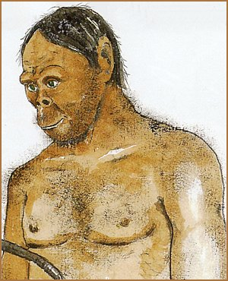Reconstruction of ‘Java man’
New information uncovered by that persistent iconoclast of evolutionism, Stephen Jay Gould, shows beyond doubt that this is a misleading picture.¹
Dubois had a highly eccentric theory of human evolution, which demanded a precise mathematical relationship between increasing brain size and body weight. In fact, by insisting that his ‘Java ape-man’ had the proportions of a gibbon (thus changing the reconstructed body-weight) he was ensuring that the ratio would fit neatly into his (erroneous) mathematical series. The purpose was to more firmly cement its status as a perfect ‘link’. Dubois himself is quoted as having written in 1932:
’Pithecanthropus was not a man, but a gigantic genus allied to the gibbons … I still believe, now more firmly than ever, that the Pithecanthropus of Trinil is the real “missing link.”¹
The idea that Dubois changed his mind about ‘Java man’ will die hard, among both evolutionists and creationists.

Racism—a consequence of evolution?
by Lita Sanders and Gary Bates
Image: Smithsonian Magazine¹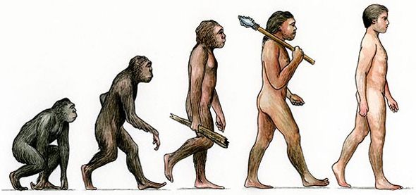An icon of evolutionism. Apes-to-humans often shows ancestral hominids as dark skinned.
What’s wrong with this picture? More blatantly than most, it typifies the racism inherent in a lot of human evolutionary progressions. Did you notice that the transitional hominid just before the end (second from right) looks like a modern-day African (albeit a bit scruffier), while the pinnacle of human evolution is a ‘white’ European-looking man? Why is a white person as a representative of modern humans, when a majority of the world’s population has medium-brown skin, eyes, and hair coloration? The subtle message here is that lighter skin means that the individual is more evolved.
The shocking thing is that this image isn’t from a fringe white supremacist group, but from the highly respected Smithsonian.com website, as an illustration to its ‘Top ten daily consequences of having evolved’ article.¹ And in the comments under that article (at the time of writing—a month after the Smithsonian article’s posting), not one commenter noticed the blatant racism in the image. Why is this?
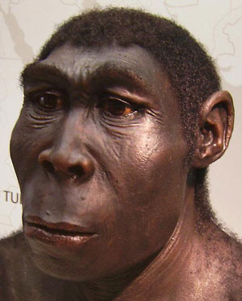Many comments argued that the darker coloration of earlier evolutionary forms was from fur or darker hair. However, this Homo erectus sculpture from a German museum exhibit which opened in 2006 shows how this is not a one-time aberration or faux pas. Notice the detail used in selecting the skin colour and hair type.
There’s no question that evolution when applied to explaining the origins of humankind, from its inception, was a racist idea. In the CMI documentary The Voyage that Shook the World, the Cambridge-educated evolutionary historian Peter Bowler stated, when talking about Darwin:
“That by the time he writes the Descent of Man in 1871 it’s pretty clear that he by that time shares the growing suspicion or conviction of many Europeans. The non white races simply do not have the capacity to be elevated properly into civilized human beings that they are mentally and morally at a more limited level. In a sense they are stuck at an early stage in the biological evolution of the human species.”

More ape-like = less evolved
Darwin himself thought of certain groups of dark-skinned people as closer to apes than their melanin-deprived counterparts. Indeed, it’s notable that the very people who came up with the theory of evolution and embraced it most passionately—upper-class European men—happened to be the ones who represented the pinnacle of evolution in their own minds. Evolutionary theory still soundly endorses the idea that humans evolved from apes. Many will have heard of the claims that human and chimp DNA are around 98% similar. This is now shown to be a myth, yet it is still cited by most scientists and laypeople as an evidence of ape-to-human ancestry. Also see Greater than 98% Chimp/human DNA similarity? Not any more.
However, when a biologist calls mankind an evolved ape, that’s seen as a scientifically accurate statement!
This evolutionary myth is the reason why it’s seen as racist or politically incorrect to call a black person a ‘monkey’. For instance, an image was deleted from Google which blended the US First Lady’s picture with that of a monkey as being offensive and racist. But similar pictures exist of nearly every unpopular political figure, including several white presidents. See our article on how the International Soccer Federation (FIFA) tried to take steps to halt the abuse of black soccer players with monkey chants and ape-like noises emanating from the crowds. See Do monkeys play football? But when a biologist calls mankind an evolved ape, that’s seen as a scientifically accurate statement!

The fruit of evolution-based racism
In fact, this evolutionary idea that various races were less evolved than others, while it was in vogue, had devastating consequences for black and mixed-skin-toned people across the world. Early Darwinists suggested that Australian Aborigines might be the missing link and many were killed to be put on display in science museums around the world.
The highlighted text reads:
‘It also appears Aborigines were murdered to obtain specimens for science and were killed for display. A death-bed memoir written by Korah Il. Wills, a gold-rush emigrant who became the mayor of Bowen in Queensland, contains confessions about the killing of an Aborigine who was later used for display’
One of Darwin’s close friends, Charles Kingsley, also colloquially known as Darwin’s quisling, even suggested that:
“The Black People of Australia, exactly the same race as the African Negro, cannot take in the Gospel … All attempts to bring them to a knowledge of the true God have as yet failed utterly … Poor brutes in human shape … they must perish off the face of the earth like brute beasts.”
The Bulletin, November 12. 1991, pp. 30–38.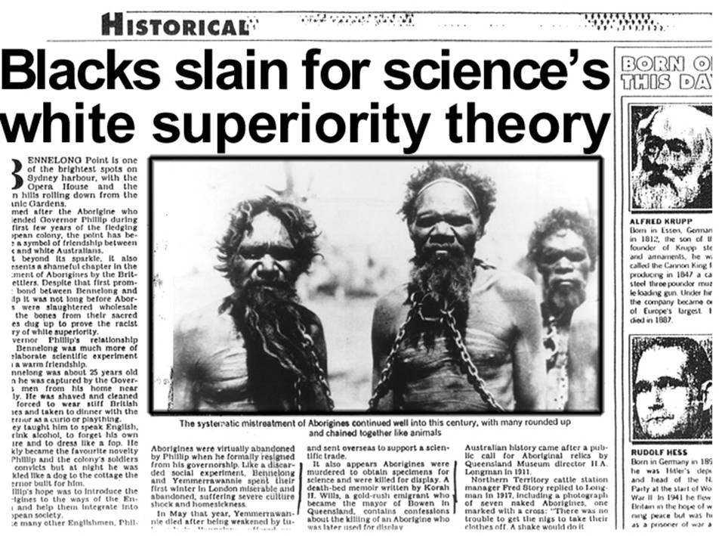Researcher, David Monaghan, spent 18 months documenting atrocities perpetrated in the name of science. It culminated in a documentary called ‘Darwin’s Bodysnatchers’.
Thus evolutionary ideas justified the later mistreatment of the Aborigines in Australia, including removing “half-blood” children (this remained government policy until the 1970s), who were thought to be more evolved than their parents, from their homes. These are now called the stolen generation. [Ed.note—Debate still rages on this issue. It is acknowledged that not all removals were for such reasons, and that some claims to be part of this generation have turned out, upon investigation, to be unsubstantiated. It is also acknowledged that some children were provided with greater opportunities than they might otherwise have had remaining in the ‘bush’. But such cannot be used to justify a horrifically flawed policy based on ‘race’, and the emotional trauma of such a forcible removal cannot be overstated.]
However, see this article of how one white Aussie was able to donate a kidney to his best mate (buddy) who was a full-blood Aboriginal . This aptly demonstrates that organ donation from a different race or people group does not preclude a successful outcome. And occasionally people exhibit characteristics of a ‘race’ from which they have no ancestry.
Evolutionism cannot adequately provide a logical foundation for treating people equally. But if they got it so badly wrong then, why should we trust their science now?
Nazi Germany’s philosophy of racial hygiene deemed blacks to be one of the lower races; after Jesse Owens won four gold medals at the Berlin Olympics in 1936, Hitler criticized Americans for even permitting a black man to participate in the games. Albert Speer, Hitler’s chief architect, who was also his armaments minister during part of World War II, said:
Each of the German victories, and there were a surprising number of these, made him happy, but he was highly annoyed by the series of triumphs by the marvelous colored American runner, Jesse Owens. People whose antecedents came from the jungle were primitive, Hitler said with a shrug; their physiques were stronger than those of civilized whites and hence should be excluded from future games.²
In America in the early 20th century, an African pygmy named Ota Benga shared a cage with an orangutan and was put on display in the Bronx Zoological Gardens as an example of a less-evolved type of human.
Many evolutionists get very angry when we point out the damage done to countless human beings as a result of a faulty evolutionary worldview. That’s because most evolutionists today aren’t racist, because the science (modern genetics) has caught up with what the Bible has clearly said all along—that all humans are incredibly closely related. But a century ago, they claimed that their evolutionary ‘science’ was correct, and such views were taught in the majority of the Western world’s public schools. But if they got it so badly wrong then, why would we trust their interpretation of science now?

A biblical worldview—the true and historically-based answer to racism
It is noteworthy that the abolitionist movement came out of a Christian worldview. The great British anti-slavery advocate, William Wilberforce, believed that all men were created equal and “in the image of God”. Even though the ‘science’ of his day could not account for the similarity of all human beings (in fact, they were more likely to notice the differences), Wilberforce took a stand on the Bible. Yet this view would not be vindicated by science until many years after his death. This is a cautionary lesson for all Christians who choose to compromise with evolutionary theory. Evolution cannot provide an adequate and logical foundation for treating people equally. Even today, the leading lights of evolution are condoning the Nazi-like practices of the past by advocating eugenics, as Darwin himself did. See Dawkins and eugenics and The Holocaust and evolution.
Real observational science demonstrates that the genetic variations of all human beings, regardless of skin colour, eye shape, or size is less than one percent of the total sum of our DNA. The finding that all humans are closely related, so much so that ‘race’ is a biologically meaningless (manmade) term, is no surprise to biblical creationists, who believe that all human beings are descended from Adam and Eve who lived about 6,000 years ago (and who probably had medium-brown skin, hair, and eyes, like the majority of earth’s population today). In fact, we’re even more closely related than that—every person alive today is descended from Noah and his three sons, who with their wives were the only people to survive the worldwide flood. So our closest common ancestor was only around 4,500 years ago. Also see Adam, Eve and Noah vs modern genetics.
Photo: Gary Roberts, worldwidefeatures.com.Which of these twins is more evolved? See Two-tone twins.
The variations in appearance that are the major determining factor in ‘racial’ classification are primarily cosmetic. For instance, coloration is controlled by one pigment—melanin—of which darker people have more, and lighter people have less. The amount of melanin is controlled by the number of melanin-producing cells, called melanocytes; dark-skinned people have more while light-skinned people have fewer. Other differences in appearance, such as the almond-shaped eyes of Asian people, are the result of similarly minor differences.
So where did these differences in appearance come from if we’re all closely related? The most likely explanation is that the Tower of Babel event, when mankind’s languages were confused, separated family groups who were forced to spread across the world. These family groups probably contained a mix of traits, but certain ones became fixed, with other traits being selected against because of their environment or living conditions. For instance, light skin would be a disadvantage in places like Africa or Australia, where skin cancer would be a major concern due to the hot climates. This is because lots of melanin that results in darker skin acts as a natural sunscreen. In Europe, especially during the Ice Age, people with lighter skin would be more able to absorb vitamin D from the sun, so they would be more able to survive. But that there is a limit to this process is evident from the Eskimo population who has middle-brown skin, and the South Americans who live in an equatorial climate, yet also have middle-brown skin.
The Gospel of Jesus Christ, the Creator, is the greatest force against racism, because every descendant of Adam is offered salvation through Christ equally, regardless of race or class. For the believer, “there is no Gentile or Jew, circumcised or uncircumcised, barbarian, Scythian, slave or free, but Christ is all, and is in all” (Colossians 3:11). When Paul was proclaiming the Gospel to the Athenians, he declared that “from one man He made all the nations, that they should inhabit the whole earth” (Acts 17:26).

From ape to man via genetic meltdown: a theory in crisis
A review of Genetic Entropy & The Mystery of the Genome by John C. Sanford,
Ivan Press, Lima, New York, 2005
by Royal Truman
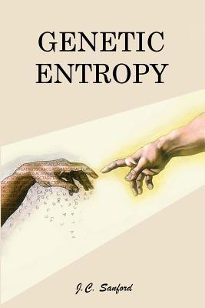
I write this review with very mixed feelings. On the one hand, for the first time some key data are being divulged which we need to include in our models, and which honest thinkers who question evolutionist theory need to digest. But I have a problem. In the Prologue professor Sanford wrote, ‘I knew I would be at odds with the most “sacred cow” of modern academia. Among other things, it might even result in my expulsion from the academic world.’ I know John personally and treasure his intelligence and integrity. In further drawing attention to his book, I may be contributing to having his ties to academia severed, a world to which he has such strong emotional ties and to which he has made so many contributions. I know academics and journalists who have already lost their jobs for questioning Darwinian theory.
He is not exaggerating. I myself have also had my experiences in this matter.
‘I started to realize (again with trepidation), that I might be offending a lot of people’s religion,’ he confides early on. How correct he is. I recently discussed the issue of life’s origins with a dear friend I’ve worked together with for years. He brought up three arguments contra creation which I easily answered on strictly scientific terms. Suddenly he leaped to his feet. Trembling with rage he pointed a finger at me, and yelled that what I was doing was dangerous! The fundamentalists in America are dangerous! They are fighting against tolerance! They refuse to accept science! They are irrational and have no facts!
Dr Sanford is an applied geneticist semi-retired from Cornell University and now with the Institute of Creation Research. He is also the inventor of the ‘gene gun’, widely used in the genetic modification of crops. In this book the reader is confronted with compelling reasons to reject the claim that mutations plus natural selection have led to the marvels found in nature.
Many scientists do not believe man is merely the product of random mutations plus natural selection, what Sanford calls the Primary Axiom. One line of reasoning, that of irreducible complexity, has been very capably championed by professor Behe:¹ molecular machines require many complex components, the absence of only one rendering that entity non-functional. Evolutionary processes cannot be expected to provide the necessary building blocks.
Others have argued that the high fidelity of DNA replication leads to very low rates of mutation. Developing humans from an ape-like forefather would just take too long. In a much cited paper, Drake has estimated² that the rate of spontaneous mutations for humans is about 5 x10^{–11} nucleotides per generation. In some 6 million years from a claimed split from the chimpanzee lineage, no humans could be generated if this is true.
Sanford forces us to recognize clearly that the relentless net effect of random mutations is degradation or complete destruction of function.
Sanford was a practising evolutionist and at heart a eugenicist (p. 116), who ‘gradually realized that the seemingly “great and unassailable fortress” which has been built up around the Primary Axiom is really a house of cards. … Its apparent invincibility derives largely from bluster, smoke, and mirrors’ (Prologue). But we will learn that evolutionary theory fails on grounds most people did not suspect.

Mutations are bad
Sanford forces us to recognize clearly that the relentless net effect of random mutations is degradation or complete destruction of function. After decades of research, if even one mutation out of a million really unambiguously created new information (apart from fine-tuning), we would all have heard about it by now (p. 17). This is to be distinguished from certain changes in for example bacteria (p. 19), which merely fine-tune a component of a system already in place. The changes typically involve modification of one or two nucleotides, and in huge bacterial populations these are usually already present, a solution waiting for the precise niche. In other words, ‘When we use a rheostat to dim a light, we are not creating a new circuit, nor are we in any way creating new information’ (p. 19).
Mutagens have been used for years in plant breeding, creating billions of mutation events: mostly small, sterile, sick, deformed and aberrant plants (p. 25). One improvement, low phytate corn, was caused by mutations which damaged the metabolism of phytic acid, making hungry cows happy, but hardly explaining the origin of this biochemical process (p. 25). ‘However, from all this effort, almost no meaningful crop improvement resulted. The effort was for the most part an enormous failure, and was almost entirely abandoned’ (p. 25).
Indeed, no one is suggesting replacing incubators with X-ray machines to help evolution along. On the contrary, health policies are in place aimed at reducing or minimizing mutations (p. 15).

Disastrously high mutational rates
Now Sanford provides a key fact, inimical to evolutionary theory, but fully consistent with the Second Law of Thermodynamics. The genetics community now accepts that point mutations in human reproductive cells are in the range of at least 100–300 per individual each generation (p. 34). In fact, additional kinds of mutations, such as deletions, insertions, duplications, translocations, inversions, micro-satellite mutations and all mitochondrial mutations exacerbate the situation. Mitochondrial mutations alone would add about another mutation per individual each generation within the reproductive cell line, and macro-mutations can generate more sequence divergence than all point mutations combined. The overall contributions imply more than 1,000 nucleotide changes in every person, every generation (p. 37).
Using the unrealistic lower bound of 100 mutations, and assuming 97% of the genome has no function, implies three new relevant mutations per individual each generation are generated (p. 34). Before someone attempts to shrug off these new findings, let us evaluate whether it is true that only 3% of the human genome is relevant. If the percent is twice as high, then we would double the proportion at risk through mutations.

Junk DNA or masterpiece?
The genome is full of countless loops and branches—like a computer program using analogue and Boolean logic.
Driven by an incorrect model, genomes are generally characterized as chaotic and full of meaningless evolutionary relics. The irony is that the more advanced the organism, the more so-called ‘junk DNA’ is claimed to be present (p. 37). Perhaps we should be exposing our babies to radioactivity after all?! Biochemists discover ever more complex metabolic networks, with elaborate regulatory schemes to provide feedback inhibition or acceleration. The genome is full of countless loops and branches—like a computer program using analogue and Boolean logic. It has genes that regulate genes that regulate genes, able to set in motion complex cascades of events (p. 3).
But the fact that research is steadily decreasing the proportion of supposed non-functional DNA has not been properly integrated into evolutionist thinking. ‘In just a few years, many geneticists have shifted from believing that less than 3% of the total genome is functional, to believing that more than 30% is functional—and that fraction is still growing’ (p. 21). Seriously now, when we examine organisms, such as dolphins, swallows or humans, do we get the impression of final products driven by a chaotic information processing system? In any event, in our thinking we need to start getting used to the fact that over 30 new genetically relevant, function-altering mutations occur per individual each generation.

Unity of complexity
Reductionist, materialistic thinking prevents more effective reasoning constructs from being developed. If we could understand to the finest detail the properties of all atoms in a computer we’d still fail to grasp the logic of algorithms programmed to solve a mathematical problem. We would not even suspect its existence. None of the individual components of an airplane can fly, but the integrated unity can. The purpose of a back-up in-flight computer may appear to be ‘parasitic junk’, especially if we limit our analysis to the material properties of the atoms it is constructed with. When it is to be brought into action, why and in response to what circumstances, would not be discerned by researching individual characteristics such as atomic vibrations and molecular rotations and bond strengths.
Before we assume that the information in the genome used to generate mature organisms is mostly junk, we would be wise to examine the final morphological product with more humility.

Good and bad mutations inseparable
Are mutations really causing all that much damage? Many Hollywood stars (and my wife!) sure seem awfully attractive. Since interchange of the genes provided from the father and the mother occurs, might this not provide a means of avoiding passing on defective genes? Might not ‘bad’ sperms and eggs lead to defective offspring which simply don’t survive, leaving many ‘good’ versions in the population? Well, unfortunately not. A huge number of mutations are added to the germline of every baby born, and these are spread throughout the various chromosomes. Human nucleotides exist in large linked clusters or blocks, ranging in size from 10,000 to a million, inherited in toto, and never break apart (p. 55, 81). A desirable trait will be accompanied by an undesirable trait, within the same individual (p. 79).
Therefore, within any physical linkage unit, on average, thousands of deleterious mutations would accumulate before a beneficial mutation would arise (p. 82). All of the individual 100,000–200,000 linkage blocks in genomes are deteriorating.
Furthermore, recombination appears to be primarily between genes rather than randomly between nucleotides. This means that an inferior gene is doomed to remain in that lineage, unless a back-mutation occurs, which is vanishingly unlikely. This means that the good mutations and the bad mutations cannot be separated, another example of the one-way direction of degradation known as ‘Müller’s ratchet’.
Being now clearly persuaded that the net effect of mutations will be loss of information-guided functionality, we are ready to digest another insight. Tragic as a devastating mutation may be to the affected and family, the effects of this ‘curse’ would be limited to the victim if no offspring survive. But for the population as a whole, the major damage turns out not to be the severe mutations.

Near neutrals
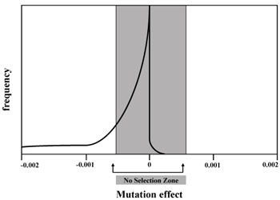Figure 1. Far more mutations are deleterious than advantageous. Individually, most have too small an effect to be acted upon by natural selection (p. 32).
The majority of deleterious mutations have individually a negligible effect on viability of the organism. This is especially true if the ‘competitors’ are also accumulating non-deadly but nevertheless undesirable mutations. This is like the rusting of a car, one iron atom at a time (p. 72). Even one extra unnecessary nucleotide is slightly deleterious—as it slows cell replication and wastes energy (p. 21).
This issue has been mostly ignored in the literature. Mutations in the ‘near-neutral box’ (figure 1) are redefined as being completely neutral, and so dismissed. It is then claimed that more severe mutations to the left of the near-neutral box can be entirely eliminated by natural selection (p. 23). I supposed that if we are talking about a very small number of mutations this would be to a first approximation reasonable. But the accumulation of dozens or hundreds of such mutations every generation presents a totally different picture.
Incidentally, we must remember that essentially all hypothetical beneficial mutations also fall within Kimura’s ‘effectively neutral’ zone (p. 24). Therefore, positive selection would also be too weak to have an effect!
It would be desirable if natural selection could remove at least some damaging mutations. In fact, this remains our last hope to avoid a fitness meltdown. Before abandoning hope, we need to consider natural selection carefully.

Natural selection is ineffective
The same environmental factor is unable to severely penalize different deleterious mutations. It is not realistic to invoke strongly negative selection to quickly eliminate a large number of unrelated mutations. As the number of minor mutations increases, each mutation becomes noise for the others (pp. 77, 78).
Now, in a laboratory one can intelligently favour natural variability to accentuate some chosen trait (p. 98). This requires carefully crafting the external environment (nutrition, temperature, natural enemies, etc.) to minimize mutational noise. Nevertheless, no one has ever claimed to have created brand new functions not already coded for on the genome in this manner. And inevitably the organisms fine-tuned in the laboratory for a single trait are less viable long-term, living freely in nature where all natural ranges of environmental challenges occur. It is possible to optimize things such as the amount of sugar a beet produces, as long as this plant is later protected from full competition with the original stock. The changes may be in man’s interest, but at the price of the organism’s natural fitness (e.g. the large sugar production might result from a mutation damaging its control mechanism so it over-produces; in the wild, this could not compete because it is wasting valuable resources).
Outside of the laboratory the matter is much worse. There is no intelligent guidance. The judge is also nearly blind (p. 7). There is a very long chain of events separating the direct effects of a genetic change and the consequences for the whole organism level. There is a logarithmic dilution at each step, a huge loss of cause-effect resolution and correspondence. ‘It is like measuring the impact of a butterfly’s stroke—on a hurricane system which is a thousand miles away’ (p. 49). ‘It is a little like trying to select for a specific soldier, based upon the performance of his army’ (p. 49).
The literature is full of statements and abstruse computer programs claiming natural selection can perform near miracles.^{3–5} But after 25 years of searching, I have yet to find an analogy or computer model backing up this claim which has any biological relevance. Generally it is enough to simply ask what kind of organism would be suitable to check and perhaps calibrate the claims against, to reveal the irrelevance. Sanford offers an illustration of how natural selection really works, which reflects formally the issues involved very realistically, which I will modify to maximize correspondence to how selection really works in nature (p. 50).
Let’s imagine a new method for improving biochemistry textbooks. A few students are randomly selected who will get a biochemistry textbook each semester during the next four years, whether or not they take a biochemistry course. Each new book will have 100 random changes in the letters. Those receiving the textbook are forced to read it (whether they take the biochemistry course or not). Different teachers assign grades to all courses taken by all students across the country each semester (whether they received the biochemistry textbook or not). The correlation between true ability and each grade (math, history, Latin … ) is weak and often wrong. At the end of the semester we compare the average grades of all students nationwide and identify from among the best students those in possession of a mutated biochemistry textbook. Each of these latter textbooks are borrowed, 100 new random changes are made, and then returned to the owner. The whole cycle of reading and grading is repeated, multiple times. Will a better textbook result in this manner? No, since there is no meaningful correlation between the small differences in textbooks and the grades. Too many other factors (‘noise’), such as home life, lack of sleep, classroom setting etc. override the effect of a few misspellings.
Any trait such as intelligence, speed or strength depends on gene characteristics and environmental factors (nutrition, training, etc.) (p. 90). For example, height is about 30% (h² = 0.3) heritable. For complex traits such as ‘fitness’ heritability values are low (i.e. 0.004). ‘This is because total fitness combines all the different types of noise from all the different aspects of the individual’ (p. 91). Low heritability means bad genotypes are very difficult to eliminate. Survival becomes primarily a matter of luck, and not better genes:
‘If Kimura’s estimate is correct, then 99.6% of phenotypic selection for fitness will be entirely wasted. This explains why simple selection for total phenotypic fitness can result in almost no genetic gain.’ (p. 93)
Natural selection is a probabilistic matter. ‘Mother Nature’ does not compute for each member of a population a ‘total fitness value’ based upon all phenotypic traits (p. 94).
Furthermore, almost all mutations are recessive, camouflaging their presence and hindering selection against them (pp. 56, 76). Another consideration, not explicitly brought out in this book, is that key environmental factors (disease, temperature, mutation, predators, etc.) affecting survival vary over time. Strong selection must be present for a huge number of generations if fixation of a (temporarily) favourable trait throughout a population is to occur. Relaxation for just a few generations could undo this process, since selection for a different trait would then be at the expense of the preceding one.
We must recognize clearly this lack of strong correlation between a mutation (whether having a positive or negative effect) and reproductive success. It is a fact of nature, yet most people attribute incorrectly near miraculous creative powers to natural selection.
But then how could natural selection supposedly develop optimized proteins, such as enzymes, one nucleotide mutation after the other, leading to almost identical versions throughout nature?^{6–8} Each improved nucleotide would have to be selectable in the presence of all the other noise-causing mutations within the same linkage blocks. This cannot occur by somehow selecting for superior individuals on average—which inherently involves thousands of different genes and millions of different nucleotides (p. 117).
We conclude that evolutionary theory has a major problem. If mutation/selection cannot preserve the information already within the genome, it is even more difficult to argue that billions of slight improvements were selected gradually over time (p. 106). The matter is not merely an issue of low probabilities. Theoretically a huge number of offspring could be generated, each differing by many random mutations. Might not a lot of luck bordering on the miraculous cherry-pick out the best? Not really. Sanford explains why there are physical constraints as to what natural selection could do in the real world.

The cost of selection
The number of offspring which humans can produce is rather small. For a human population to maintain its size, about three individuals per couple would be needed. This is because not all who live go on to have children, due to personal choice, accidental death, etc. Eliminating individuals carrying bad mutations would require that additional children be born, to be sacrificed to natural selection (p. 57). ‘All selection has a biological cost—meaning that we must remove (or ‘spend’) part of the breeding population’ (p. 56). In other words, deleterious mutations in man must be kept below one mutation for every three children for flawless, 100% effective selection to be able to eliminate all the mutations and still allow the population to reproduce (p. 32).
There are several kinds of costs, all additive, which must be paid for before ‘real’ selection can be covered (p. 59).⁹ As mentioned above, fitness has low heritability, meaning environmental factors are much more important than genetic factors in determining who survives. This means that a very large number of additional offspring is needed, which must die due to natural selection independent of genetic causes, simply to remove non-heritable variations (p. 59). In these circumstances, having to additionally select the worse culprits which carry 100 or more mutations, every generation, is not physically possible (p. 62).

Haldane’s Dilemma
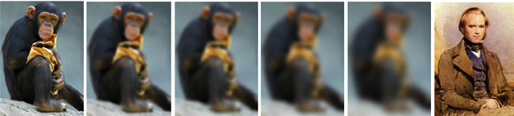A process which steadily degrades a genome cannot produce a better organism.
Having demonstrated conclusively that the degradation of the human genome (in the presence of such high mutations rates, preponderance of deleterious mutations and lack of huge expendable proportions of offspring) cannot be avoided, we return to what evolutionary theory claims happened. Ever more complex and sophisticated genomes are supposed to have arisen, step by step, over eons.
In the 1950s, one of the most famous population geneticists, John Burdon Sanderson Haldane, presented an observation known as ‘Haldane’s dilemma’ (p. 128): it would take (on average) 300 generations to select a single new mutation to fixation. However, his calculations were only for independent, unlinked mutations. He assumed constant and very strong selection for a single trait, which is not realistic. The interference by hundreds of random mutations was not taken into account. Even so, selection for only 1,000 specific and adjacent mutations could not happen in all putative evolutionary time. There is no way an ape-like creature could have been transformed into a human (p. 129). Man and chimp differ at roughly 150 million nucleotide positions (p. 130) and humans show remarkably little variation worldwide.

Think for yourself
Advanced education is dominated by evolutionary theory taught as established fact. But ‘are you really just a meaningless bag of molecules—the product of nothing more than random molecular mutations and reproductive filtering?’ (Prologue). This doctrine is presented as unquestioned truth, an axiom accepted by faith because many scientists present it as obviously true (p. 5). But if you come to the point where you feel that the Primary Axiom is no longer obviously true to all reasonable parties, then you must not accept it on blind faith (p. 10). At best the materialist model could be basically right, but it is absurd to continue believing that it is self-evident. At the very least, critical thought and fair discussion is required, something scorned and denigrated by the current high priests of biology.
Historically, the entire field of population genetics was developed by a small, tightly knit group of people radically committed to the Primary Axiom. They were free to explore many scenarios and adjust multiple parameters unconstrained by objective calibrations, and to optimize frameworks to appear internally consistent. Their mathematical approach was to define the unit of selection as discrete genetic units, such a gene or nucleotide, instead of whole organisms with all the contradictory influencing factors (p. 52).
‘For the most part, other biologists do not even understand their work—but accept their conclusions “by faith”’ (p. 46). The theorists’ models can be shown to never have matched biological reality to the minimal degree expected of useful models, but these men were undeniably intelligent and had an incredible aura of intellectual authority (p. 53). In many ways they deserve our admiration, since transforming any scenario, correct or not, into an appropriate mathematical formulation requires a great deal of skill. One can also admire honestly the brilliant lawyer who argues ever so cleverly against the truth in his client’s interest. How we wish they would contribute their gifts within a correct paradigm!

There is hope
Finally, professor Sanford makes it clear that no amount of human intervention can salvage the relentless degradation of our genomes. We will experience much and increasing suffering on the part of our children and grandchildren. But our Creator made the genome in the first place.
‘ … Jesus is our hope … He gave us life in the first place—so He can give us new life today. He made heaven and earth in the first place—so He can make a new heaven and earth in the future’ (p. 155).
Read this book twice. Then read it again with a highlighter. Technical aspects are easy to follow, and the specialist will benefit very much for the highly relevant references offered.

